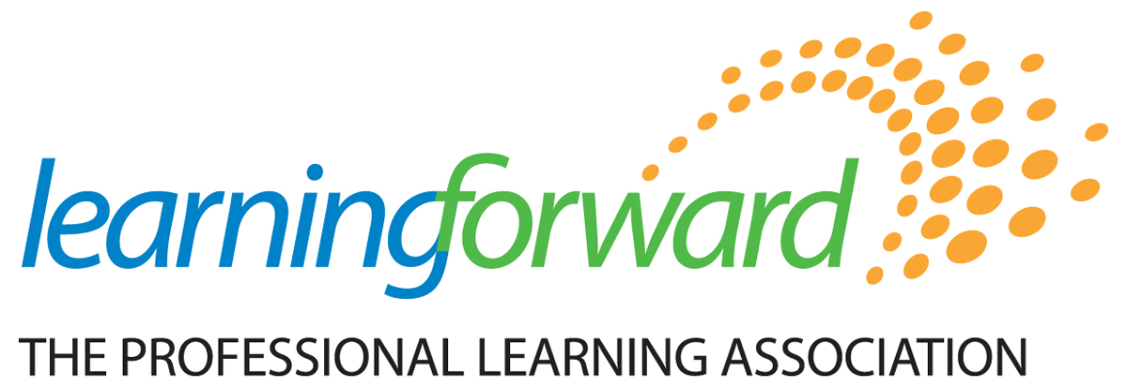
Affiliate Membership Form

Join your state’s Affiliate today!
For more information on affiliate benefits please go to: http://www.learningforward.org/get-involved/affiliates

Participating Affiliates:
State/Province Contact Name Phone Annual Dues Check Affiliate
Arizona | Eric Brooks | 480-406-0841 | $25
Arkansas | Marion Woods | 501-447-3391 | $5
British Columbia | Sue Elliott | 604-885-3936 | $5
California | Kathie Laurence | 408-718-6996 | $50
Colorado | Anne Knapp | 303-755-6631 | $45
Georgia | Janet Johnson | 770-853-0811 | $30
Illinois | Karla McAdam | 217-520-2562 | $35
Indiana | Laura Link | 901-483-3977 | $25
Kansas | Jill Lachenmayr | 316-218-4674 | $30
Maryland | Antoinette Kellaher | 301-367-2091 | $30
Michigan | Amy Colton | 734-645-5995 | $50
Minnesota | Laurie Resch | 763-506-3802 | $30
Mississippi | Karen Burke | 601-636-8980 | $20
Missouri | Jody Wood | 314-977-2481 | $30
Nebraska | Amy Poggenklass | 402-476-8055 | $25
Nevada | Nicolette Smith | 775-861-1298 | $30
New England States (CT, MA, VT, ME, RI) | Maida Williams | 617-527-3293 | $30
Ohio | Georgina Collette | 614-777-7912 | $35
Pennsylvania | Kathy Gibson | 215-805-3114 | $5
South Carolina | Karen Bullard | 803-438-3591 | $30
Texas | Terri Iles | 817-614-9865 | $5
Washington | Ellen Hopkins | 509-924-2694 | $30

Total Amount Due: ______________
Please include current mailing address:

Name: __________________________________________ E-mail: ________________________________________

School/Org.: _____________________________________ Phone: ________________________________________

Address: ____________________________________ Fax: _______________________________________

City/State/Zip: ________________________________ Title: ______________________________________

Payment Information:

▢ Check Enclosed (payable to Learning Forward) ▢ Purchase Order Enclosed

▢ Credit Card #: ____________*____________*____________*____________Signature:______________________
(Visa, MasterCard, American Express or Discover)

Exp Date: _______/_______ Three digit security code: __________
Submit to Learning Forward, 504 S Locust Street, Oxford, OH, 45056 or via fax: 513-523-0638

